ZDJĘCIE | NUMER | DESCRIPTION | COLOR | QTY | EURO
 |  | glass flower pot
 | 883422400 | 13x13 cm | orche | 1174 | €
 |  | glass flower pot
 | 882964800 | 13x13 cm | hemlock | 546 | €
 |  | glass flower pot
 | 882747000 | 13x13 cm | erica | 528 | €
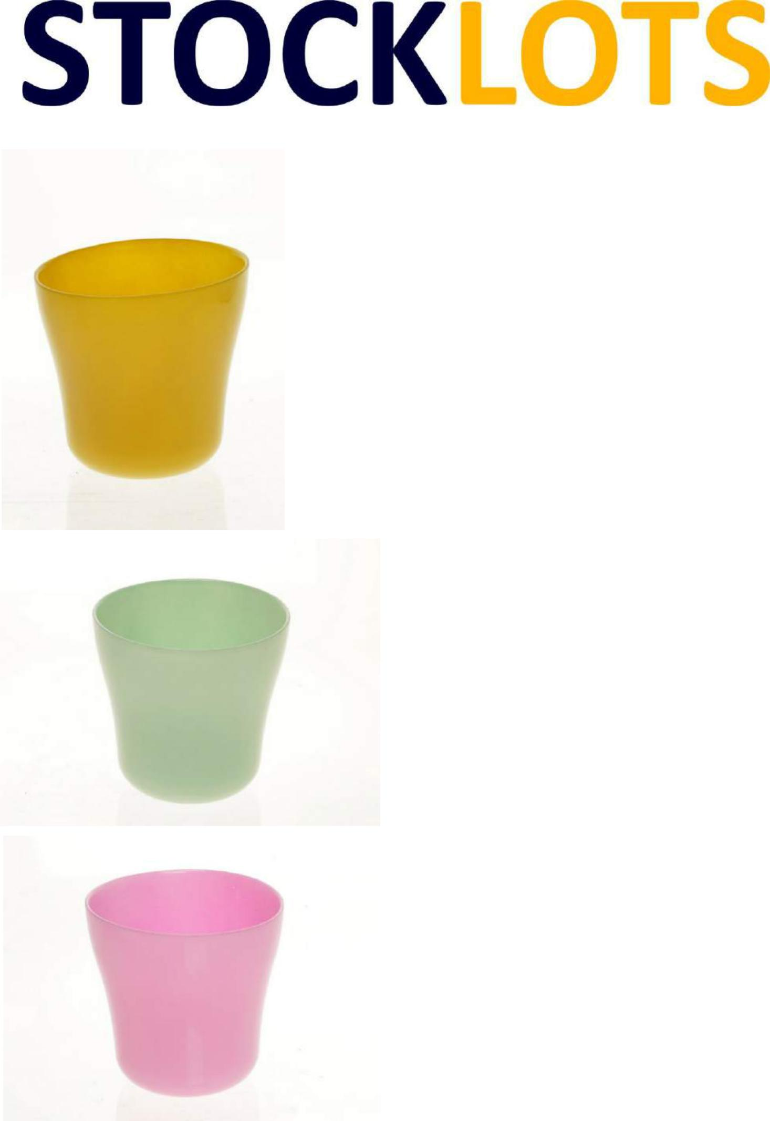

Strona 1

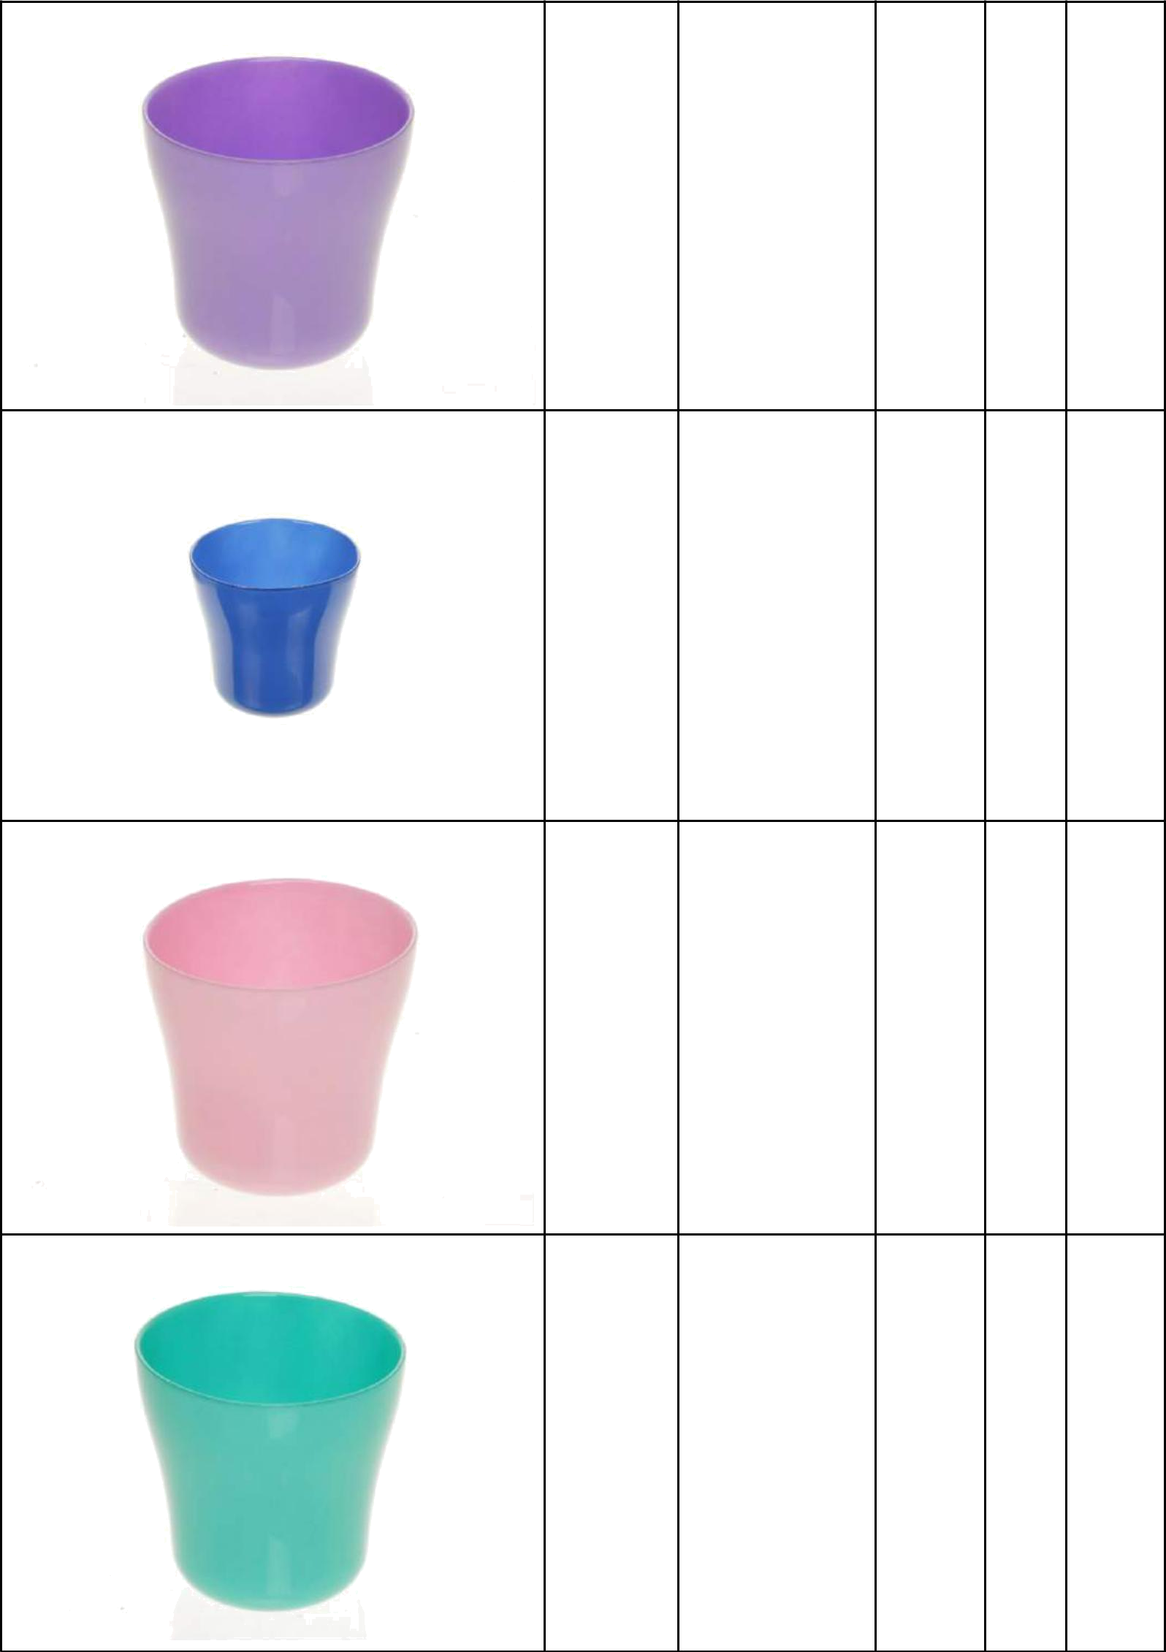

glass flower pot
882964400 13x13 cm | tulip | 660

glass flower pot
882939700 13x13 cm | blue | 555

glass flower pot
882746800 13x13 cm | pink | 435

glass flower pot
882755200 13x13 cm | emerald 4499

Strona 2
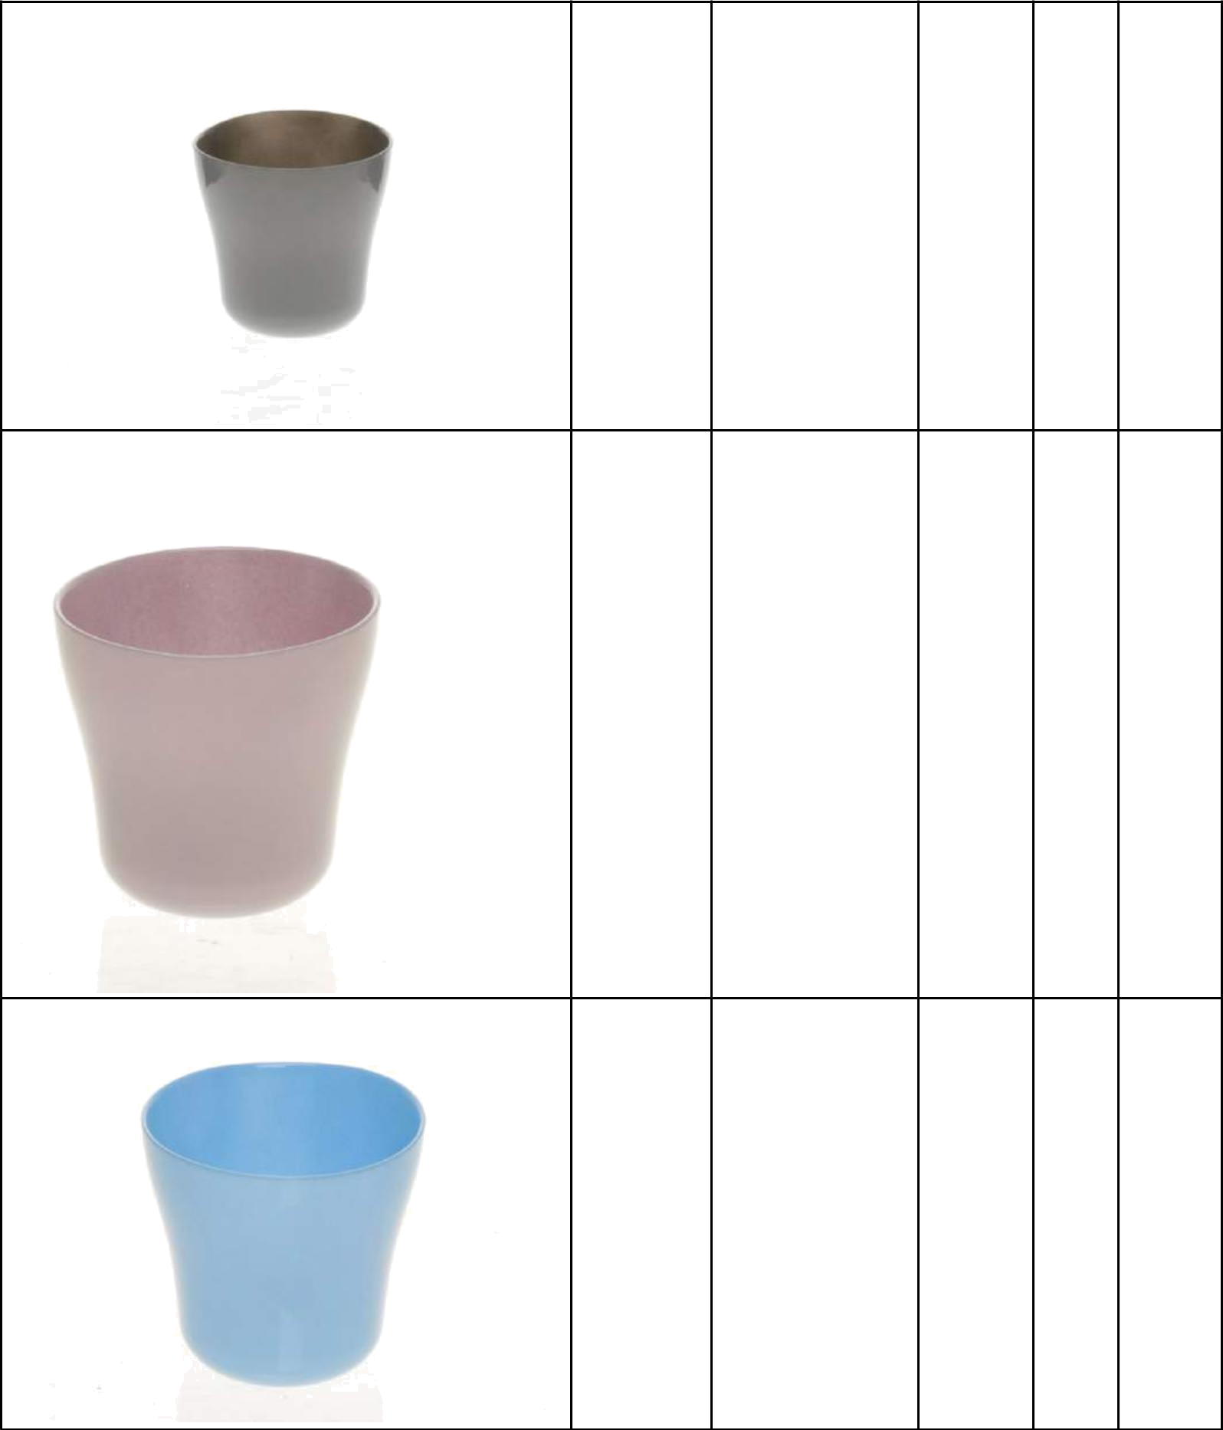

glass flower pot
882939800 13x13 cm | grey | 150

glass flower pot
883422500 13x13 cm | taupe | 85

glass flower pot
882964700 13x13 cm | placid | 1293

Strona 3

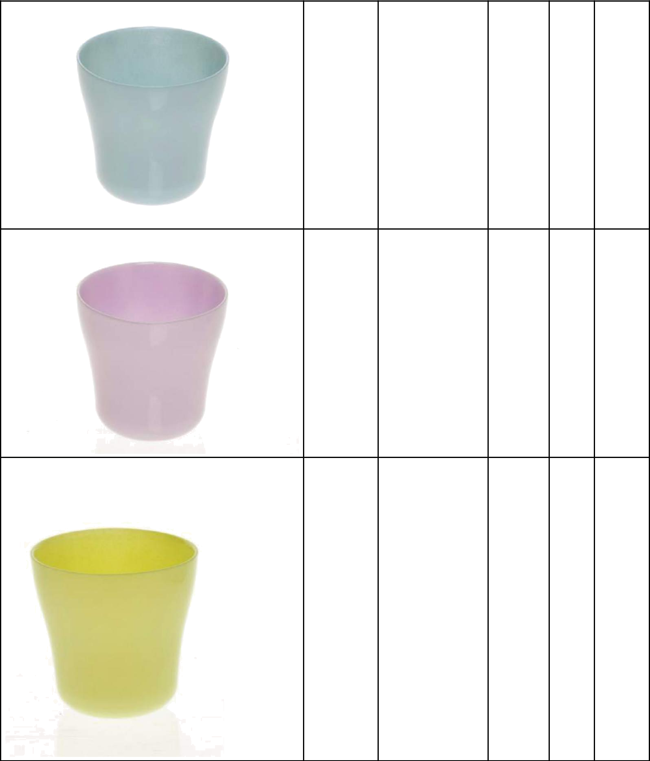

glass flower pot
882747300 13x13 cm | blue | 1673

glass flower pot
882746900 13x13 cm | lilac | 1260

glass flower pot
883422200 13x13 cm | anise | 562

Strona 4

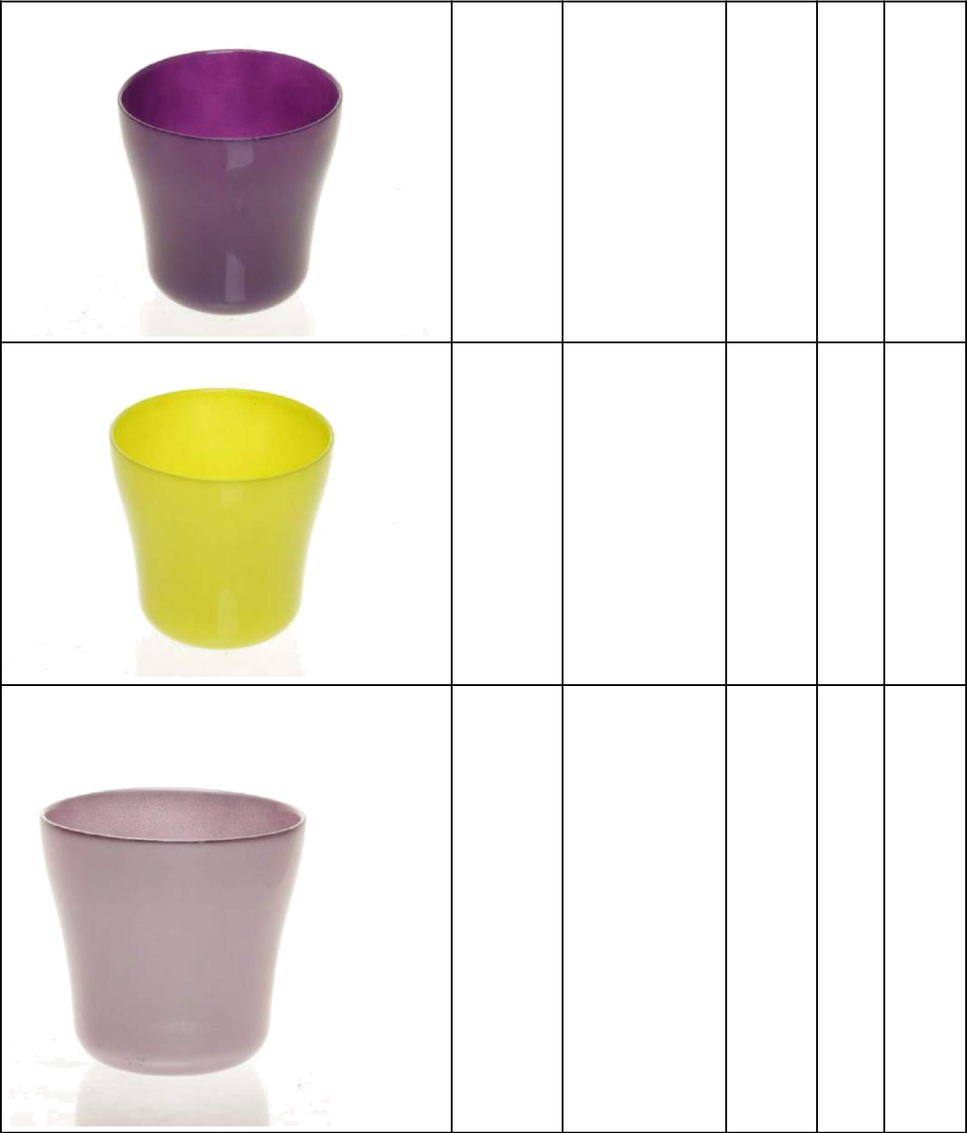

glass flower pot
882747100 13x13 cm | lilac | 476

glass flower pot
882746600 13x13 cm | lime | 1704

glass flower pot
882747900 13x13 cm | pink | 1515

Strona 5

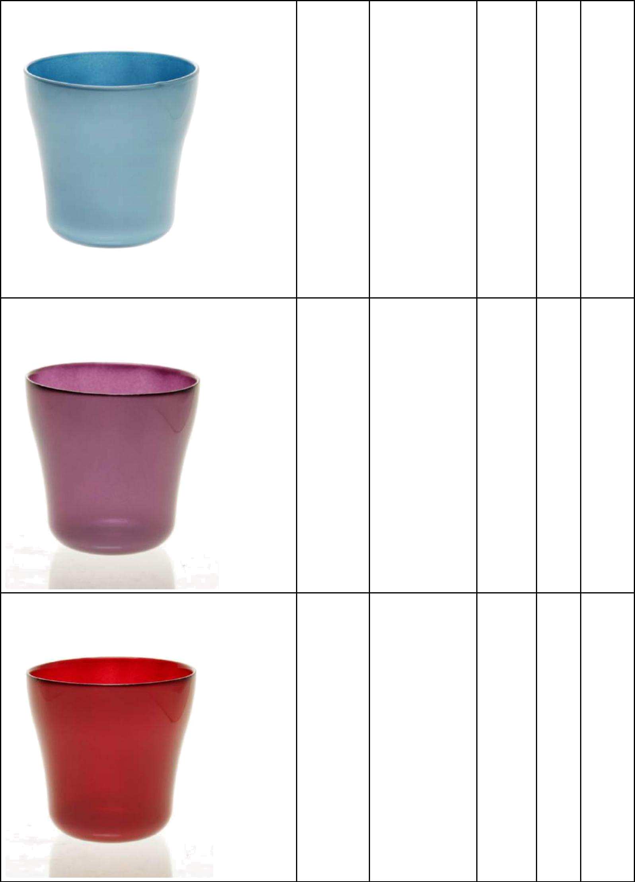

glass flower pot
882748300 13x13 cm | blue | 4086

glass flower pot
882747800 13x13 cm | purpul | 1792

glass flower pot
882748000 13x13 cm | red | 698

Strona 6
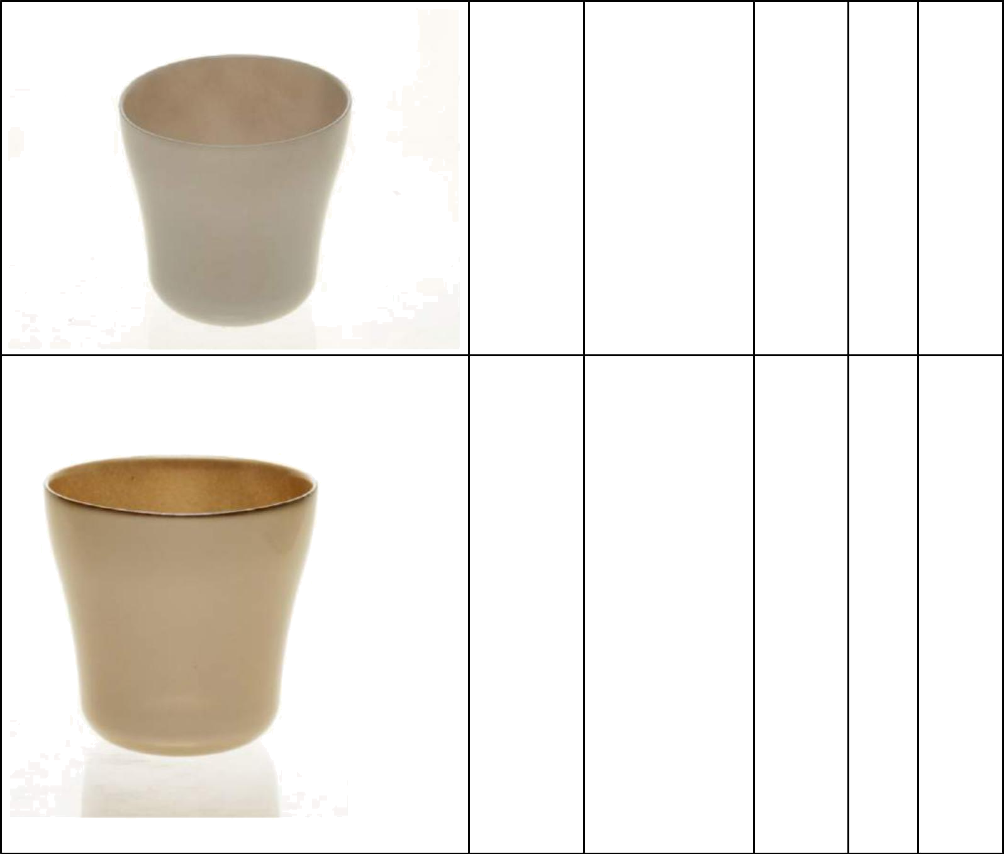

glass flower pot
882747400 13x13 cm | grey | 373

glass flower pot
882747500 13x13 cm | gold | 480
 |  | 24544

Strona 7

